What’s a Career Tree?
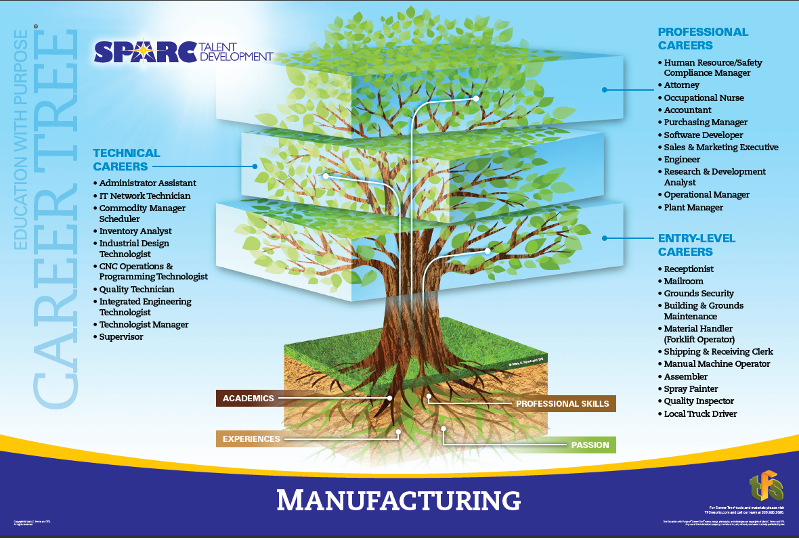
The Career tree is designed to promote discussion on employment opportunities and the pathways to different careers.

The first set of branches represents Entry Level Careers.

Technical Careers make up the second level as students gain the education required to reach this level such as certification, associates degree or apprenticeship.

The highest branches show the Professional Careers available if students push education further with a four-year or master’s degree.

SPARC Talent Development is excited to have their Career Coaches use these trees to promote conversation with students AND parents as they look at the options before them. We also want to highlight the importance of a strong root system made up of: Academics, Professional Skills, Experience and Passion.

If you have an event targeting parents and their students and would like to borrow our career trees, please visit our website: www.sparc-talent.org and use the contact form to request access.
SPARC Talent Development is a 501(c)3 organization comprised of leaders in industry, business and education, regional foundations and economic development groups.

We welcome those who are passionate about developing our region and working with educators to help students make informed choices about their futures and the future of our communities.

